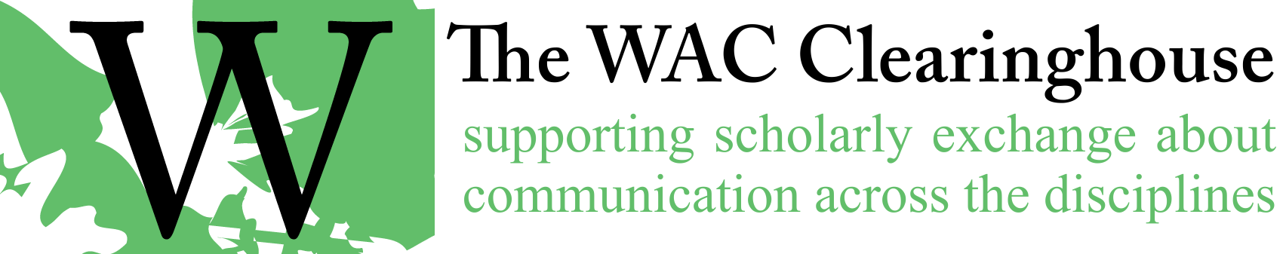

**Email Template for Issuing Contracts**

Hi [Author(s)/Editor(s)],

I’ve issued a contract for your book with the WAC Clearinghouse’s Name of Series book series. You should see a message from Adobe asking you to sign the contract. If you don’t see that message, please check your spam or junk mail folder. If worst comes to worst, I can always resend it.

Congratulations on the contract – and thank you for willingness to share your work in open-access formats through the Clearinghouse. We hope that you find the experience working with us a good one and that you’re as pleased as we are to be part of the large community of scholars who have contributed to the discipline through the Clearinghouse.

I’ve attached a couple of documents that I hope you will review and work on. First, I’ve attached a copy of our marketing information form. While we don’t market in the same way that a commercial publisher does, our print partner (University Press of Colorado) does. And our series editors and associate editors use this information to set up reviews, develop awards nominations, and so on. I’ve also attached a file that I will use for the Library of Congress Data (and another file that shows how to fill it out). This information will help us prepare the Library of Congress Cataloguing in Process information and can help market the book. The sooner it is submitted (which I’ll do as soon as I have the final manuscript from you), the sooner we can move into print. Finally, I’ve attached an updated copy (with some recent minor changes) of our style guide. Please check this out carefully (it will help me a great deal when we get to production if you do). And if you see areas in which it can be improved, please let me know.

A few quick notes:

* When you are ready to provide the final manuscript, please do so as a single file in Microsoft Word format. Please avoid, if at all possible, the use of Google Docs. We’ve had some fairly serious problems with importing content from that platform. We understand that it’s not possible to avoid using it in some cases, particularly on collaboratively written chapters, but please prepare the final manuscript in Word itself.
* The document should use styles, as discussed in our guide for authors and editors. We’ve provided some fairly clear information about using styles in our guide. Please review them prior to sending us your final manuscript.
* If you are using any figures or images, please check our guidelines for graphics preparation carefully. We produce our work at a resolution of 600 dots per inch. It’s advisable to provide images to us that have a pixel width of at least 2400.
* If you are thinking you might produce an index for the book, please read the relevant sections of the guide. We’re happy to help with this process.

You’ll see a checklist early in our style guide. Please work though it prior to sending us your final manuscript. If you have any questions that I can help with, please feel free to reach out to. Again, thanks and congratulations.

All the best,