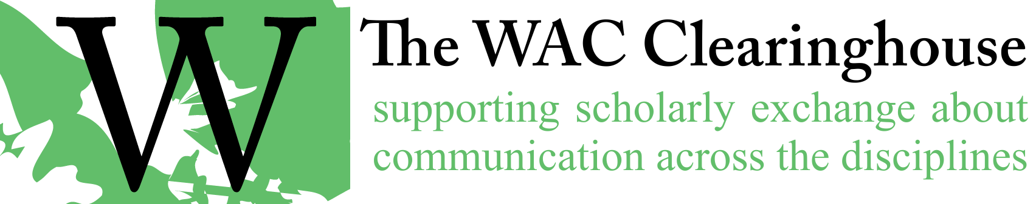

**Email Template for Review of Copyedits**

Hi [Author(s)/Editor(s)],

Our copy editor has completed work on your book. The next step in the process of producing the book is your review of the edits. I’ve attached a Microsoft Word document that uses tracked changes and comments. Please do not edit the document in anything other than Word at this point. We’ve learned that moving back and forth between word processing programs can cause some unfortunate changes to the document and can complicate our production process.

In case you are unfamiliar with tracked changes or use it rarely, here are some suggestions for using it well.

1. You’ll find the controls for tracked changes in the Review ribbon in Microsoft Word. As you work on the document, please be sure that you’ve turned off tracked changes in the document. This way, any changes you make to the document won’t be tracked and it will produce a cleaner document. At this point, we don’t need to see what you’ve accepted or rejected, added or removed. We simply want to get a clean document back from you – one you’re happy with.
2. Please respond to all changes by accepting or rejecting them. We assume two things about these changes. First, it might be the case that the copyeditor has found a mistake or noted an issue that you might want to address (e.g., a missing citation or a request to clarify something). If you agree with the change, accept it or address the issue. Second, it might be that the copyeditor has made a judgment that you don’t want to accept. In that case, please reject the change. You can accept or reject changes by right clicking on the change and choosing accept or reject.
3. Once you’ve responded to a comment, please delete it.

Please note that the attached document does not show any formatting changes (all of which are also kept track of when tracked changes are turned on). Because it is easier to see important changes to the manuscript if you ignore formatting changes, I’ve accepted all of them. This would include, for example, any missing italics in a reference list entry.

[Additional notes from the copyeditor and/or queries, concerns that have come up. Global changes you might have made.]

**[Use for edited books] Here’s an important point:** To simplify our production process, we’d like you to share the individual chapters with your authors and ask them to accept or reject changes. Before you do this, I encourage you to work through the manuscript and accept or reject changes that you feel should be addressed before sending the chapters to your authors. For example, you might accept or reject changes that apply across the entire document. You might also add your own comments for your authors.

Here’s a message you might send to your contributors.

Dear [Author],

Copyediting on our book is now complete. We’d like you to review your chapter. You should do so in Microsoft Word if at all possible, since formatting styles have been applied to the document and moving the document to another word processing program (such as Google Docs) can often remove those styles. If you don’t have access to Word, please note that when you respond, and we’ll restore the styles to the chapter.

Please return your chapter to us **by no later than DATE and TIME**. Thanks,

You might wish to include a copy of the Clearinghouse style guide (attached to this message) in your messages to your authors.

**Here’s another important note:** Please keep in mind that this is the last point at which you and your authors will be able to make substantive changes to the manuscript, such as the addition of citations and expansion of content. Once you return your approved manuscript to me and we move into the production stage, we’ll be interested only in ensuring that no errors have survived the copyediting process. Of course, we recognize that things can change, so this is a rule that can be broken. But it’s a rule that should be broken only rarely, particularly because the proof you’ll see will be laid out quite tightly. Please make sure you pay particular attention to the manuscript at this point. It will be the last opportunity to strengthen your argument and ensure that you’ve been as clear as you can be.

And please, as always, pay special attention to references (both in text and in references lists). I spot checked the manuscript and didn’t see many problems, but this is a common area where oddities can work their way in.

[Include the following only if they haven’t returned the CIP data and/or marketing information form.] Finally, in case you haven’t filled it out yet, I’ve attached a copy of our information form. We don’t do marketing in any traditional sense, but our print partner does. I’ve also attached a file that we will use for the Library of Congress Data (and another file that shows how to fill it out). This information will help us prepare the Library of Congress Cataloging in Process information. The information in these files will also help me prepare the back-cover and website copy for the book. My hope is that you’ll send this to me without delay.

**Regarding an Index:** I’ll add that, should you wish to create an index, I’d like you to reach out to me. It’s important, for example, that you use Microsoft Word to create your index. Its indexing tools are easy to use, and the index entries transfer seamlessly into InDesign. If you choose to create an index, we can provide you with advice that will help you save time and avoid common mistakes.

As I mentioned above, I’ve attached a copy of our style guide. Please review the submissions checklist at the beginning of the guide. It is important that you ensure that you have addressed each point in the checklist. In particular, please note the requirements for use of word processing styles, ensuring links are live, and providing ALT tags for images. These are the things that are often overlooked or missed. Should you need any clarifications about style issues or conventions used by the Clearinghouse (our house style attempts to straddle the MLA and APA documentation styles), please get in touch with me or [name of series editor(s)].

Once we receive the manuscript from you, we’ll begin the process of designing the book at that point. In a few weeks (perhaps longer, depending on schedules), you’ll see a page proof for your book.

Congratulations on your progress on the book. We’re looking forward to moving on to the next step in the production process.

All the best,