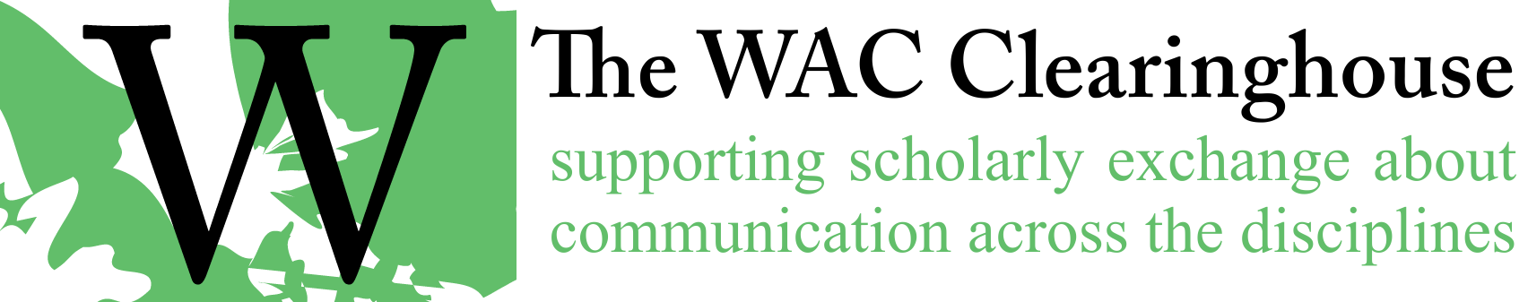

**Email Template for Review of the Web Page and Final PDFs**

**For Edited books**

Hi [Author(s)/Editor(s)],

Thanks for your work on the page proofs. I’ve incorporated your edits and I’ve put a copy of the book on the web for you to review. You’ll find it at <https://wac.colostate.edu/books/perspectives/threshold/>. It’s in pretty good shape, but you’re almost certain to find things to change before we announce the book. At this point, I’d like you to ask your contributors to take a final look at the book. When you do so, please let them know that we won’t make any changes to correct anything other than egregious errors (i.e., no changes because of minor stylistic infelicities, no additions of yet another footnote, and no new source citations). I will, of course, correct errors. At this point, the book is tightly laid out and, in some chapters, I had to work particularly hard to get everything to line up properly. If we change the length of a paragraph, that can have unfortunate ripple effects.

If you would collect the corrections and send them to me, that would be very helpful. As soon as I have the corrections, I’ll finalize the PDF, create the DOIs (they’re in the book but not created and registered – I’m waiting until pagination is final), create the ePub, announce the book on the lists, and send it off for print production

A key issue at this point is ensuring that your authors do not announce the book’s availability. We want to wait to do that until we have the final book on the web. With the large number of contributors you have in this book, you might find that difficult to avoid, but I hope that we can attempt to do so nonetheless.

Here’s a message you might send to your contributors. I know you’ve already given them a heads up, but this might be useful.

Dear Authors,

Our book is now available on the web for you to review your chapters. PLEASE do not announce this book to your friends or on the lists or anywhere as it is still undergoing a few changes in preparation for print production. You can find the book at <https://wac.colostate.edu/books/international/eac2018>.

You may download your chapter/s and develop a list of such edits as typos and institutional affiliations. (Because we are in the late stages of publication, the publisher wants to preserve its integrity, so we don’t want to make changes of substance that would change the line length of a paragraph.) Let us know if there is anything of concern to you.

 Send your edits to the PDF file of your chapter to me **by no later than DATE and TIME**. Any changes that come in after that cannot be guaranteed for print copy of the book and may not make it into the web version either.

Thanks for all of your work on the book so far. I’m looking forward to announcing it.

All the best,

**For Authored Books**

Hi [Author(s)/Editor(s)],

I’ve put a copy of the book on the web for you to review. You’ll find it at <https://wac.colostate.edu/books/international/grounded/>. It’s in pretty good shape, but you’re almost certain to find things to change before we announce the book. As I noted in my notes about the first proof, I’m hoping to restrict edits to errors and other mistakes as opposed to stylistic changes. I’ve laid the book out carefully, and in some chapters it’s actually quite tight. If we change the length of a paragraph, that can have unfortunate ripple effects.

Once I hear from you, I’ll make the last set of corrections, create the ePub, link the book to the series and main book pages, and take care of the DOIs and OCLC listings.

Thanks for all of your work on the book so far. I’m looking forward to announcing it.

All the best,

**For NCTE Books**

Hi [Author(s)/Editor(s)],

I’ve attached a final proof for you to review. It’s in pretty good shape, but you’re almost certain to find things to change before NCTE is ready to release the book. As I noted in my notes about the first proof, I’m hoping to restrict edits to errors and other mistakes as opposed to stylistic changes. I’ve laid the book out carefully, and in some pages it’s actually quite tight. If we change the length of a paragraph, that can have unfortunate ripple effects.

Once I hear from you, I’ll make the last set of corrections, create the ePub, send the book to NCTE, and wait for them to give the word to create the Web page. I’ll also add the Library of Congress info, which should be available by then.

Thanks for all of your work on the book so far. I’m looking forward to seeing it out in the world.

All the best,