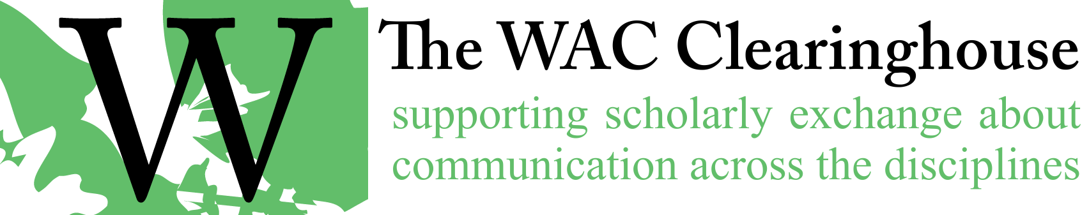

**Notes on Accessibility**

[From the *Bedford Research*, 8e] Accessibility involves ensuring that your document can be read or viewed by everyone. Key strategies for ensuring accessibility include:

* providing closed captions and transcripts for audio and video recordings; including alternate descriptions (“alt” tags) for images, tables, and other illustrations in digital documents and websites
* making sure the colors you use contrast sufficiently to meet the needs of readers or viewers who are color blind
* using headings and subheadings to convey the structure of a document
* providing information — usually through the “properties” dialog box — about the title, author(s), subject, and keywords associated with a document

You can learn more about accessibility at www.section508.gov/create/, webaim.org, and www.w3.org/WAI/fundamentals/accessibility-intro/.

Many composing tools are designed to accommodate the needs of readers or viewers who have low or no vision. Microsoft Word and PowerPoint, for example, allow you to check a document for accessibility. (See the Review tab.) If the tool you’ve chosen lacks this functionality, consider searching the web for the name of the tool and the key word *accessibility*. [End section from the *Researcher*]

Key issues to consider:

* [Alternative text (alt text)](https://www.chhs.colostate.edu/accessibility/best-practices-how-tos/alternative-text/): Should be concise and meaningful to the listener.
* [Captions (subtitles):](https://www.chhs.colostate.edu/accessibility/best-practices-how-tos/video-captions/) Captions must be accurate and usable, and auto-captions will need to be edited manually for accommodation needs.
* [Color Contrast](https://www.chhs.colostate.edu/accessibility/best-practices-how-tos/color-contrast/): Use a contrast [checking tool](https://www.chhs.colostate.edu/accessibility/best-practices-how-tos/color-contrast-tools/), choose a color scheme that provides high contrast between the text and background, and avoid green-red and blue-yellow (or similar) color combinations.
* [Accessible PDF files](https://www.chhs.colostate.edu/accessibility/best-practices-how-tos/pdf-converted/): It is easiest to make a document (such as the syllabus) accessible in the original software, so go back to the source document (Word, PowerPoint) and re-convert to PDF.
* [Accessibility in Canvas](https://www.chhs.colostate.edu/accessibility/best-practices-how-tos/canvas/): Consider providing PowerPoint files alongside recorded lectures to make a huge impact for many students.
  + Many students use assistive technology for note-taking. Note-taking technology allows students to make notes directly on PowerPoint slides for later study.
  + Students with visual impairments and in general benefit greatly by being able to keep up with the content during a lecture or presentation.

A useful and simple tool I have been using in Canvas is the accessibility checker. This is a tool you can use right away to review the accessibility of your assignments.

* Go to an assignment and click on “edit”.
* Click on the accessibility checker icon just below the bottom of the text box:
* The accessibility checker will determine the issue (formatting lists/ changing text color) and resolve it for you.